**BUG REPORT OF TEA DIARY APPLICATION**

**Name – Ashwini Patil**

**Device – OPPO F1s**

**Android version – 5.1**

**APK Version – 1.2**

**Bug ID – 1**

**Module name** **–** All Modules

**Bug description** **–** Back arrow is not available for all the fields.

**Steps –** 1. Click on the application

2. Click on any module

**Bug Image –**

**Bug ID – 2**

**Module name –** All Modules

**Bug description –** After adding seller name it will redirect on manage menu item but when user wants to go back it will redirect on dashboard instead of seller list.

**Steps –** 1. Click on the application

2. Click on Seller option

**Bug Image:**

**Bug ID – 3**

**Module name** **–** Seller wise Item

**Bug description –** (Bill) bill is not generated properly.

**Steps –** 1. Click on the application

2. Click on Generate bill

**Bug Image:**

**Bug ID – 4**

**Module name –** Item

**Bug description –** Default item name is editable.

**Steps –** 1. Click on the application

2. Click on Item option

3. Edit item name

**Test data –** By default item name – Tea

Updated name – Momos/Shev puri/Burger

**Expected result** – Item name should not be editable.

**Bug Image:**

**Bug ID – 5**

**Module name –** Item

**Bug description –** Trimmed (having space) value is accepted for seller name.

**Steps –** 1. Click on the application

2. Enter seller name with stream value

**Test data –** “ Anuja”

**Expected result –** System should fire validation message for Invalid name (trimmed).

“Please enter valid name”.

**Bug Image:**

**Bug ID – 6**

**Module name –** Item

**Bug description –** Name field contains special/junk/Numeric values.

**Steps –** 1. Click on the application

2. Enter seller name with special/junk/Numeric values

**Test data –** Seller name “@$#*()”

Seller name “123655”

**Expected result –** System should fire validation message for Invalid name.

“Please enter valid name”.

**Bug Image:**

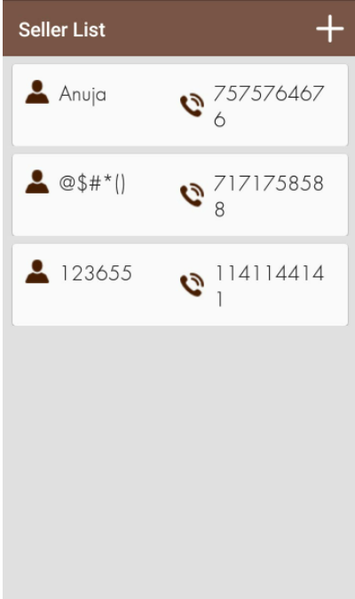

**Bug ID - 7**

**Module name –** Item

**Bug description –** Item Price is editable.

**Steps –** 1. Click on the application

2. Click on Item option

3. Edit item price

**Test data –** By default item price – 10

Updated item price – 20

**Expected result –** Item price should not be editable.

**Bug Image:**

**Bug ID - 8**

**Module name –** Item

**Bug description –** Item name contains special/junk/Numeric values.

**Steps –** 1. Click on the application

2. Click on Item option

3. Enter item name with special/junk/Numeric values

**Test data –** By default Item name “12@#3456”

Updated Item name “@$12%^”

**Expected result –** System should fire validation message for valid Item name.

“Please enter valid Item name”.

**Bug Image:**

**Bug ID - 9**

**Module name –** Seller

**Bug description –** Seller list contains Invalid Mobile No.

**Steps –** 1. Click on the application

2. Enter Mobile No.

**Test data –** Mobile No. “0000000000”

**Expected result –** System should fire validation message for valid Mobile No.

“Please enter valid Mobile No.”

**Bug Image:**

**Bug ID - 10**

**Module name –** Seller List

**Bug description –** Name field contains already existing names with uppercase and lowercase letters.

**Steps –** 1. Click on the application

**Test data –** Seller name – “anuja”

Seller name – “ANUJA”

**Expected result –** System should fire validation message for already exist name.

**Bug Image:**

**Bug ID - 11**

**Module name –** Seller List

**Bug description –** Name field contains same name with same Mobile No.

**Steps –** 1. Open the application

2. Click on the Seller List

3. Click on + icon

4. Enter Name

5. Enter Mobile No.

6. Enter Address

**Test data –** Name: Anuja/ANUJA

Mobile No. – “7075689754”

Address – “KCS IT Global”

**Expected result –** System should fire validation message for Seller is already available.

**Bug Image:**

**Bug ID - 12**

**Module name –** Seller List

**Bug description –** Name field contains same name with different Mobile No.

**Steps –** 1. Open the application

2. Click on the Seller List

3. Click on + icon

4. Enter Name

5. Enter Mobile No.

6. Enter Address

**Test data –** Name: Anuja/Anuja

Mobile No. – “7075689754”

Address – “KCS IT Global”

**Expected result –** System should fire validation message for Seller is already available.

**Bug Image –**

**Bug ID - 13**

**Module name –** Seller List

**Bug description –** Cursor focus is not visible for Name field when name field is blank.

**Steps –** 1. Open the application

2. Click on the Seller List

3. Click on + icon

4. Enter Name

5. Enter Mobile No.

6. Enter Address

**Test data –** Name: “ “

Mobile No. – “7075689754”

Address – “KCS IT Global”

**Expected result –** Cursor should be focused when name field is blank.

**Bug Image –**

**Bug ID - 14**

**Module name –** Seller List

**Bug description –** Cursor focus is not visible for Mobile No. field when Mobile No. field is blank.

**Steps –** 1. Open the application

2. Click on the Seller List

3. Click on + icon

4. Enter Name

5. Enter Mobile No.

6. Enter Address

**Test data –** Name: Anuja/Anuja

Mobile No. – “ ”

Address – “KCS IT Global”

**Expected result –** Cursor should be focused when name field is blank.

**Bug Image –**

**Bug ID – 15**

**Module name –** Seller List

**Bug description –** Blank “space” is valid for the name and address field.

**Steps –** 1. Open the application

2. Click on the Seller List

3. Click on + icon

4. Enter Name

5. Enter Mobile No.

6. Enter Address

**Test data –** Name: “_”

Mobile No. – “7075689754”

Address – “_”

**Expected result –** System should for fire validation message for blank “space”.

“Please enter name”

“Please enter address”

**Bug Image –**

**Bug ID – 16**

**Module name –** Seller List

**Bug description –** Seller List page is blank when seller is not added.

**Steps –** 1. Open the application

2. Click on the Seller List

3. Click on + icon

**Expected result –** System should for fire validation message for “No seller is available”

“Please enter seller name”

**Bug Image –**

**Bug ID – 17**

**Module name –** Seller List

**Bug description –** Name field accepts Emoji as name.

**Steps –** 1. Open the application

2. Click on the Seller List

3. Click on + icon

4. Enter Name

5. Enter Mobile No.

6. Enter Address

**Test data –** Name: “Emoji”

**Expected result –** System should for fire validation message for “Invalid Name”

“Please enter valid name”

**Bug Image –**

**Bug ID – 18**

**Module name –** Seller List

**Bug description –** Validation message is not proper when click on Delete button.

**Steps –** 1. Open the application

2. Click on the Seller List

3. Click on + icon

4. Enter Name

5. Enter Mobile No.

6. Enter Address

7. Click on Save

8. Tap on user’s detail

9. Click on Delete

**Expected result –** Validation message should be proper when user delete seller name.

**Bug Image –**

**Bug ID – 19**

**Module name –** For all modules

**Bug description –** When press on + Icon user redirect to the homepage.

**Steps –** 1. Open the application

2. Click on the Seller List

3. Click on + icon

4. Press back button

**Expected result –** User should be redirect to that particular module.

**Bug Image –**

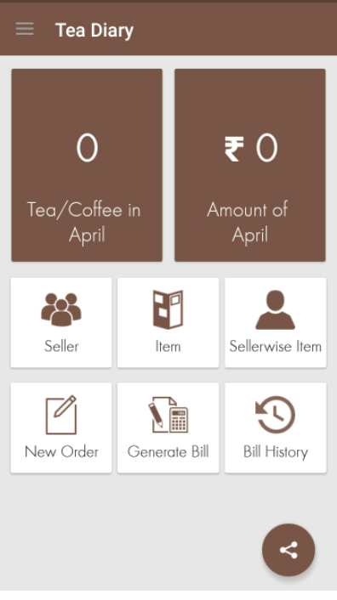

**Bug ID – 20**

**Module Name:** Item List

**Bug Description:** Validation message is not in proper place when both fields are blank

**Steps –** 1. Open Application

2. Click on the Item list Icon

3. Click on + icon

4. Click on save

**Test Data:** Name -“”

Price –“”

**Expected Result -** Validation message should be in proper place for Name and Price.

**Bug Images –**

**Bug Id- 21**

**Module Name-** Item List

**Bug Description-** Price is invisible when user want to update price.

**Steps –** 1. Open Application

2. Click on the Item list Icon

3. Click on one of the items

4. Enter item name

5. Enter Price

6. Click on Update

**Test Data-** Item name – Tea

Item price – “10”

**Expected Result –** Price should not be invisible when user updated item price.

**Bug Images –**

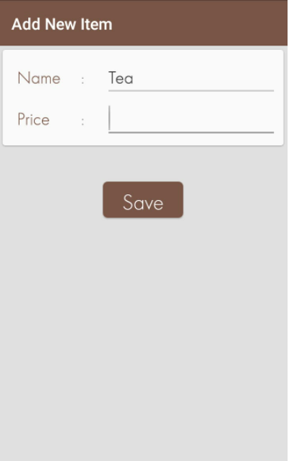

**Bug Id- 22**

**Module Name-** Item List

**Bug Description-** Cursor should be focused when name field is blank.

**Steps –** 1. Open Application

2. Click on the Item list Icon

3. Click on + icon

4. Enter blank item name

5. Enter Price

6. Click on save

**Test Data-** Name – “”

Price – “10”

**Expected Result –** Cursor should be focused when name field is blank.

**Bug Images –**

**Bug Id- 23**

**Module Name-** Item List

**Bug Description-** Cursor should be focused when price field is blank.

**Steps –** 1. Open Application

2. Click on the Item list Icon

3. Click on + icon

4. Enter item name

5. Enter blank price

6. Click on save

**Test Data-** Name – “Tea”

Price – “”

**Expected Result –** Cursor should be focused when price field is blank.

**Bug Images –**

**Bug Id- 24**

**Module Name-** Item List

**Bug Description-** Already available item name is accessible by using case sensitive text.

**Steps –** 1. Open Application

2. Click on the Item list Icon

3. Click on + icon

4. Enter item name with case sensitive text

5. Enter price

6. Click on save

**Test Data-** Already available name – “Tea”

New name – “tea”

Price – “10”

**Expected Result –** System should fire validation message for already available item name.

**Bug Images –**

**Bug Id- 25**

**Module Name-** Item List

**Bug Description-** Blank item name is accessible.

**Steps –** 1. Open Application

2. Click on the Item list Icon

3. Click on + icon

4. Enter blank item name

5. Enter price

6. Click on save

**Test Data-** Name – “”

Price – “10”

**Expected Result –** System should fire validation message for blank item name.

“Please enter item name”

**Bug Images –**

**Bug Id- 26**

**Module Name-** Item List

**Bug Description-** Numeric value is accessible as item name.

**Steps –** 1. Open Application

2. Click on the Item list Icon

3. Click on + icon

4. Enter numeric value as item name

5. Enter price

6. Click on save

**Test Data-** Name – “12”

Price – “10”

**Expected Result –** System should fire validation message for Invalid item name.

“Please enter valid item name”

**Bug Images –**

**Bug Id- 27**

**Module Name-** Item List

**Bug Description-** Special character is accessible as item name.

**Steps –** 1. Open Application

2. Click on the Item list Icon

3. Click on + icon

4. Enter numeric value as item name

5. Enter price

6. Click on save

**Test Data-** Name – “@$()#:”

Price – “10”

**Expected Result –** System should fire validation message for Invalid item name.

“Please enter valid item name”

**Bug Images –**

**Bug Id- 28**

**Module Name-** Item List

**Bug Description-** Emoji is accessible as item name.

**Steps –** 1. Open Application

2. Click on the Item list Icon

3. Click on + icon

4. Enter emoji as item name

5. Enter price

6. Click on save

**Test Data-** Name – “Emoji”

Price – “20”

**Expected Result –** System should fire validation message for Invalid item name.

“Please enter valid item name”

**Bug Images –**

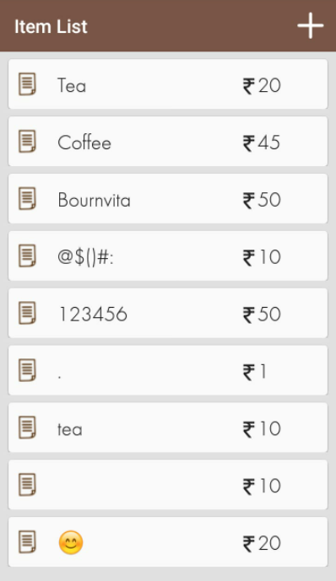

**Bug Id- 29**

**Module Name-** Item List

**Bug Description-** Item name is not proper (having minimum length).

**Steps –** 1. Open Application

2. Click on the Item list Icon

3. Click on + icon

4. Enter item name having max length

5. Enter price

6. Click on save

**Test Data-** Name – “Bourn”

Price – “25”

**Expected Result –** System should fire validation message for Invalid item name.

“Please enter valid item name”

**Bug Images –**

**Bug Id- 30**

**Module Name-** Item List

**Bug Description-** When user update item name it will allow already available item to the item list.

**Steps –** 1. Open Application

2. Click on the Item list Icon

3. Click on + icon

4. Enter item name

5. Enter price

6. Click on Save

7. Click one of the item

8. Update item name

9. Click on Update button

**Test data** – Already available item – Coffee

Updated item - Coffee

**Expected Result –** System should fire validation for already available item name

“Please add new item”

**Bug Images –**

**Bug Id- 31**

**Module Name-** Seller wise item.

**Bug Description-** When enter price Cursor focus is not on the proper place.

**Steps –** 1. Open Application

2. Click on Seller wise item

3. Check the checkbox

4. Enter item name

5. Enter price

6. Click on Ok

**Test data** – Price – “20”

**Expected Result –** Cursor focus should be in proper place.

**Bug Images –**

**Bug Id- 32**

**Module Name-** Seller wise item.

**Bug Description –** User is not able to delete the selected item.

**Steps –** 1. Open Application

2. Click on Seller wise item

3. Click on add new item

4. Enter Name

5. Enter price

5. Click on Save

**Test data** – Name - Tea

Price – “20”

**Expected Result –** Delete button must be available to delete the selected items.

**Bug Image –**

**Bug Id- 33**

**Module Name-** Seller wise item.

**Bug Description –** After saving selected items from seller, items list is not display in New order.

**Steps –** 1. Open Application

2. Click on Seller wise item

3. Select an item

4. Click on Save

**Test data** – Name – “Coffee”

“Bournvita”

Price – “25”

“50”

**Expected Result –** Selected items must be display on New Order list.

**Bug Images –**

**Bug Id- 34**

**Module Name-** New Order.

**Bug Description –** Post dates are clickable.

**Steps –** 1. Open Application

2. Click on New Order

3. Select Tea Seller

4. Select date

5. Place order

**Expected Result –** Post-dates should not be clickable.

**Bug Images –**

**Bug Id- 35**

**Module Name-** Generate Bill.

**Bug Description –** Date is not valid to generate a bill.

**Steps –** 1. Open Application

2. Click on Generate Bill

3. Select dates

**Expected Result –** Boundary box analysis should be checked for the calendar.

**Bug Images –**

**Bug ID – 36**

**Module name** **–** Seller-wise Item.

**Bug description** **–** After selecting new items will not display in New Order list.

**Steps –** 1. Click on the application

2. Click on Seller wise item

3. Select items

4. Click on Save button

**Bug Image –**

**Bug ID – 37**

**Module name** **–** Seller-wise Item.

**Bug description** **–** Item value is not extended above three digits.

**Steps –** 1. Click on the application

2. Click on Item

3. Enter item name

4. Enter item price

**Test data –** Item name: “Bhel”

Item price: “258”

**Expected result –** Item price should be extended above three digits.

**Bug Image –**

**Bug ID – 38**

**Module name** **–** Seller-wise Item.

**Bug description** **–** After generating the bill it will display the old bill as well as the total amount of old and current bill.

**Steps –** 1. Click on the application

2. Click on Generate Bill

3. Click Bill History

**Expected result** **–** Bill History should display total bill only.

**Bug Image –**

**Bug ID – 39**

**Module name** **–** Item.

**Bug description** **–** Zero value is valid as Item price.

**Steps –** 1. Click on the application

2. Click on Seller-wise Item

3. Enter item name

4. Enter item price

**Test data –** Item name: Tea

Item price: “0“

**Expected result –** System should fire validation message for Invalid Item price.

“Please enter valid Item price”

**Bug Image –**

**Bug ID – 40**

**Module name** **–** Generate Bill.

**Bug description** **–** Total bill is 100 and it will display 70.

**Steps –** 1. Click on the application

2. Click on Generate Bill

3. Click on Bill History

**Test data –** Total Bill – 100

Bill Displayed - 70

**Expected result –** System should display proper(valid) Bill for particular orders.

**Bug Image –**

**Bug ID – 41**

**Module name** **–** Seller-wise Item.

**Bug description** **–** Seller name is not able to update in Billing and other seller name is updated instead of seller name.

**Steps –** 1. Click on the application

2. Click on Seller-wise Item

3. Select checkbox for one item

4. Click on Save button

5. Click on Generate Bill

6. Click on Bill History

**Expected result –** Bill should be assigned to the particular user (Customer).

**Bug Image –**

**Bug ID – 42**

**Module name** **–** Bill History

**Bug description** **–** The total amount is not able to update after paying the bill.

**Steps –** 1. Click on the application

2. Click on Bill History

**Expected result –** Total amount should be updated after paying the bill

**Bug Image –**

**Bug ID – 43**

**Module name** **–** Bill History

**Bug description** **–** When total bill is 1090 and I’m trying to pay 1100 it will not show any validation message for Invalid Bill.

**Steps –** 1. Click on the application

2. Click on Bill History

3. Click on the price which you will have to pay

4. Click on Pay

5. Enter Paid Amount

6. Click Ok

**Expected result –** System should fire validation message for updation of bill when user (Customer) paying the bill.

**Bug Image –**

